Patient Instructions for Half Somersault for right-sided BPPV

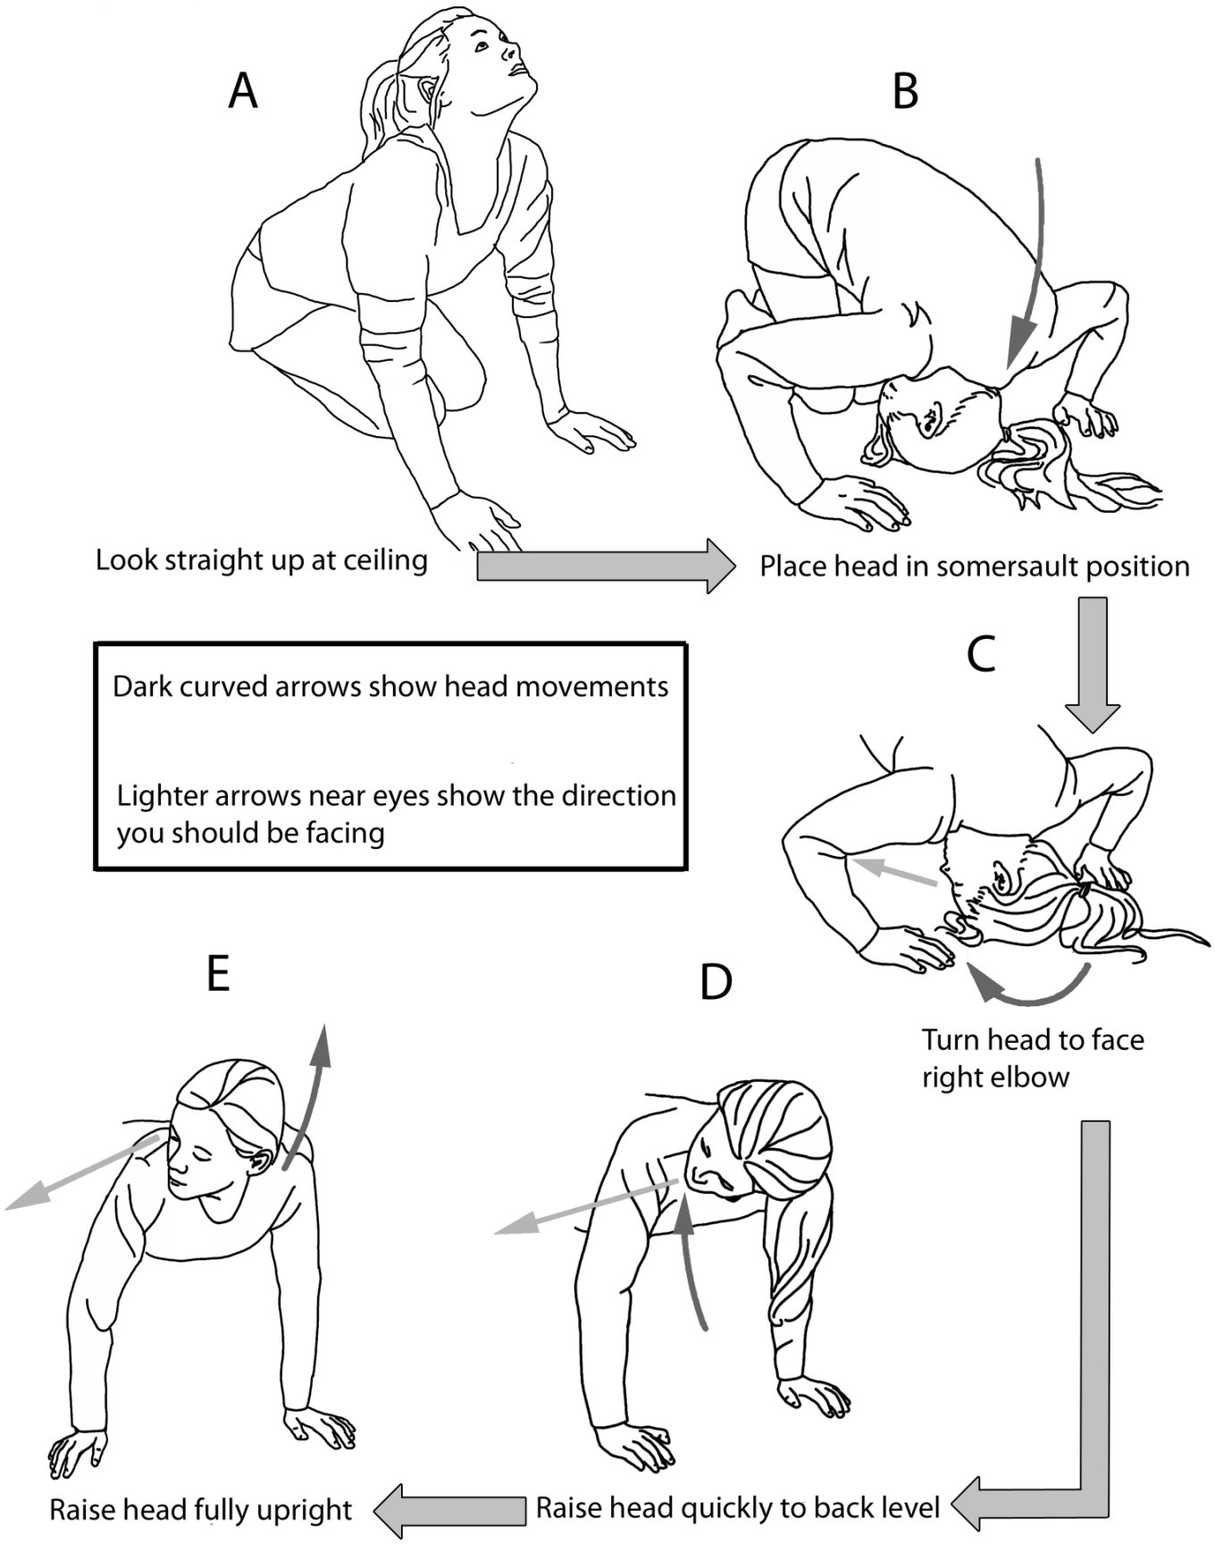

- Kneel on the floor or in the middle of a large bed. Tip your head straight upward quickly until you are looking straight up at the ceiling. This may cause dizziness briefly.
- Next place your head on the floor upside down, as if you are about to do a somersault. Tuck the chin so that your head touches the floor near the back of the head rather than near the forehead. This position may cause a burst of vertigo. Without moving, wait until any vertigo ends. The vertigo means the particles are moving in the proper direction. Tapping firmly on the skull with your fingertips just behind the right ear can help move the particles along.
- Slowly turn your head to face your right elbow. Try to center the right elbow in your field of view. You will keep your head turned to the right through the rest of the maneuver. Again, wait for any vertigo to end before moving to the next step.

- Keeping your head turned to the right and viewing your right elbow, QUICKLY raise your head to shoulder level. Your head should be positioned at about a 45º angle to the floor throughout this move. Vertigo is normal during this part of the procedure. Wait for the vertigo to end or count to 15 before continuing.

- Raise your head to the upright position QUICKLY, keeping it about halfway turned toward the right shoulder. Some additional vertigo may occur. After the vertigo subsides, slowly sit upright.
Rest for 15 minutes. After the rest, quickly tip your head up and down. If no dizziness occurs, do not repeat the maneuver. If you still feel some dizziness when making that movement, repeat the maneuver. You may also repeat the maneuver if you have another vertigo spell in the future.

Additional instructions:

Always wait at least 15 minutes between maneuvers to allow particles to settle. Sleep propped up on 2 or 3 pillows for two nights following the maneuver.
Sleep only on your left side for a week after the maneuver (put a pillow behind you to keep you from rolling over in the night).

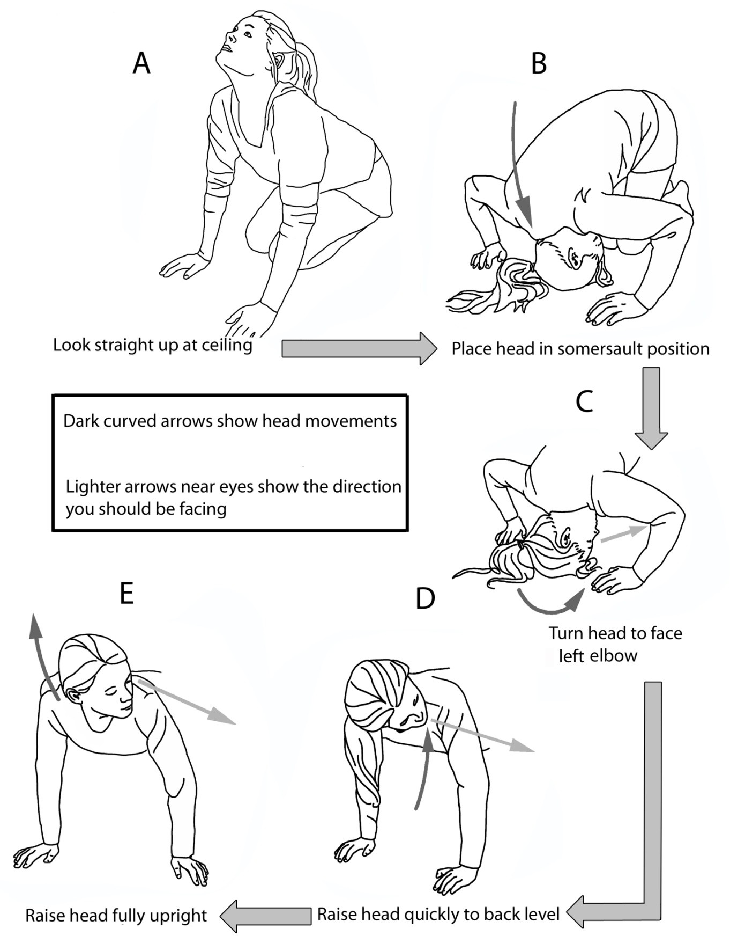

- Kneel on the floor or in the middle of a large bed. Tip your head straight upward quickly until you are looking straight up at the ceiling. This may cause dizziness briefly.
- Next place your head on the floor upside down, as if you are about to do a somersault. Tuck the chin so that your head touches the floor near the back of the head rather than near the forehead. This position may cause a burst of vertigo. Without moving, wait until any vertigo ends. The vertigo means the particles are moving in the proper direction. Tapping firmly on the skull with your fingertips just behind the left ear can help move the particles along.
- Slowly turn your head to face your left elbow. Try to center the left elbow in your field of view. You will keep your head turned to the left through the rest of the maneuver. Again, wait for any vertigo to end before moving to the next step.

- Keeping your head turned to the left and viewing your left elbow, QUICKLY raise your head to shoulder level. Your head should be positioned at about a 45º angle to the floor throughout this move. Vertigo is normal during this part of the procedure. Wait for the vertigo to end or count to 15 before continuing.

- Raise your head to the upright position QUICKLY, keeping it about halfway turned toward the left shoulder. Some additional vertigo may occur. After the vertigo subsides, slowly sit upright.
Rest for 15 minutes. After the rest, quickly tip your head up and down. If no dizziness occurs, do not repeat the maneuver. If you still feel some dizziness when making that movement, repeat the maneuver. You may also repeat the maneuver if you have another vertigo spell in the future.

Additional instructions:
Always wait at least 15 minutes between maneuvers to allow particles to settle. Sleep propped up on 2 or 3 pillows for two nights following the maneuver.
Sleep only on your right side for a week after the maneuver (put a pillow behind you to keep you from rolling over in the night).

